
PROJECT BASED LEARNING
ON

RAFT FOTTING DESIGN AND DRAFTING BY USING AUTO CAD

BY

JUTTIGA VAISHNAVI 25X01A0128
KADDURI CHARAN 25X01A0129
MANDA PRANAY 25X01A0133
RAMPALLI RISHIKA 25X01A0111

DEPARTMENT OF CIVIL ENGINEERING

NARSIMHA REDDY ENGINEERING COLLEGE (UGC- AUTONOMOUS) APPROVED BY AICTE, AFFILIATED TO JNTUH, ACCREDITED BY NBA & NAAC WITH A-GRADE)

MAISAMMAGUDA (V), KOMPALLY, SECUNDERABAD,500100.(20262027)

COMPUTER AIDED DRAFTING SOFTWARE PROJECT

RAFT FOTTING DESIGN AND DRAFTING BY USING AUTO CAD

Project Report

ON

RAFT FOTTING

Civil Engineering – Computer Aided Drafting
Narsimha Reddy Engineering College (NRCM)

ABSTRACT
A raft footing, also known as a mat foundation, is a reinforced concrete foundation system constructed over the entire or a major portion of a building area to support several columns, walls, or other structural members. It is generally adopted when the soil has low safe bearing capacity, when column loads are high, when individual footings would overlap, or when differential settlement must be minimized. By distributing structural loads over a wider ground area, a raft footing improves overall stability and helps achieve more uniform settlement of the structure.
This project presents the preparation of a raft footing drawing using AutoCAD. The work involves developing a detailed foundation plan showing column locations, grid lines, footing dimensions, thickness, edge details, pedestal locations, and reinforcement arrangements. Cross-sections and sectional elevations are also prepared to illustrate the depth of excavation, lean concrete layer, bottom and top reinforcement, cover, and connection between columns and the raft slab. Proper dimensioning, labeling, hatching, layer management, and annotation are used to make the drawing clear and suitable for construction reference.
AutoCAD plays an important role in producing accurate, neat, and easily editable engineering drawings. It enables precise scaling, quick modification of dimensions, systematic organization of drawing components, and clear presentation of reinforcement and construction details. The prepared drawing can assist structural engineers, architects, contractors, and site supervisors in understanding the proposed foundation arrangement and carrying out the work efficiently.
The project demonstrates the practical application of AutoCAD in civil and structural engineering documentation. It emphasizes the importance of correct foundation planning, load distribution, reinforcement detailing, and communication through technical drawings. The final raft footing drawing serves as a useful model for academic study and preliminary construction documentation; however, its final dimensions and reinforcement must always be designed and approved by a qualified structural engineer based on actual loads, soil investigation, and applicable design codes.

INTRODUCTION
Foundations are the most important structural elements of a building because they transfer the load of the superstructure safely to the soil. The selection of a suitable foundation depends on factors such as column loads, soil bearing capacity, groundwater conditions, settlement, and building layout. When the soil is weak or when columns are closely spaced, isolated footings may become large and overlap each other. In such situations, a raft footing is an effective and economical foundation solution.
A raft footing, also called a mat foundation, is a large reinforced concrete slab constructed beneath several columns or walls. It spreads the combined load of the structure over a wide area, thereby reducing pressure on the soil and minimizing unequal settlement. Raft foundations are commonly used for multistorey buildings, industrial structures, basements, and locations with low bearing-capacity soil.
The design and detailing of a raft footing require accurate planning of column locations, foundation dimensions, slab thickness, reinforcement, and sectional details. AutoCAD is widely used to prepare these drawings because it provides precision, easy editing, proper scaling, and clear presentation of engineering details. Using AutoCAD, the raft footing plan, reinforcement layout, cross-sections, and construction notes can be prepared in an organized and professional manner.
This project focuses on the drafting and detailing of a raft footing using AutoCAD. It aims to develop a clear foundation drawing that can help engineers, contractors, and site personnel understand the footing arrangement and carry out construction accurately.

AIM AND OBJECTIVES OF THE PROJECT
Aim
To prepare a detailed raft footing drawing using AutoCAD for the safe and effective distribution of structural loads to the supporting soil.
Objectives
- To understand the purpose and application of raft footing in building construction.
- To study the conditions in which a raft foundation is preferred over isolated footings.
- To prepare an accurate raft footing layout showing grid lines and column locations.
- To draft footing dimensions, slab thickness, pedestal details, and sectional views in AutoCAD.
- To provide reinforcement details for the top and bottom of the raft slab.
- To include proper dimensions, labels, annotations, hatching, and construction notes.
- To develop clear and professional structural drawings suitable for academic and preliminary construction reference.
- To improve proficiency in using AutoCAD for civil and structural engineering drafting.

DRAWING DIMENSIONS
TOP VIEW

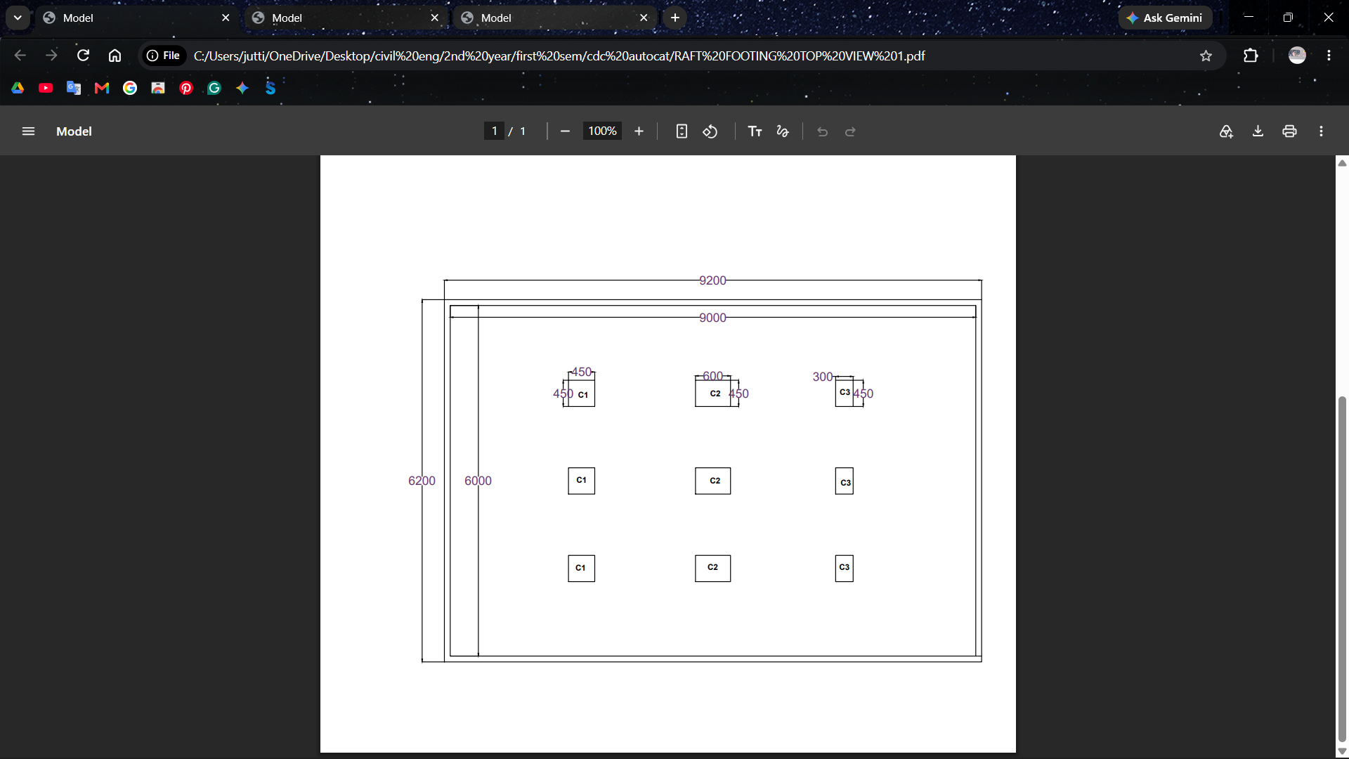

SIDE VIEW

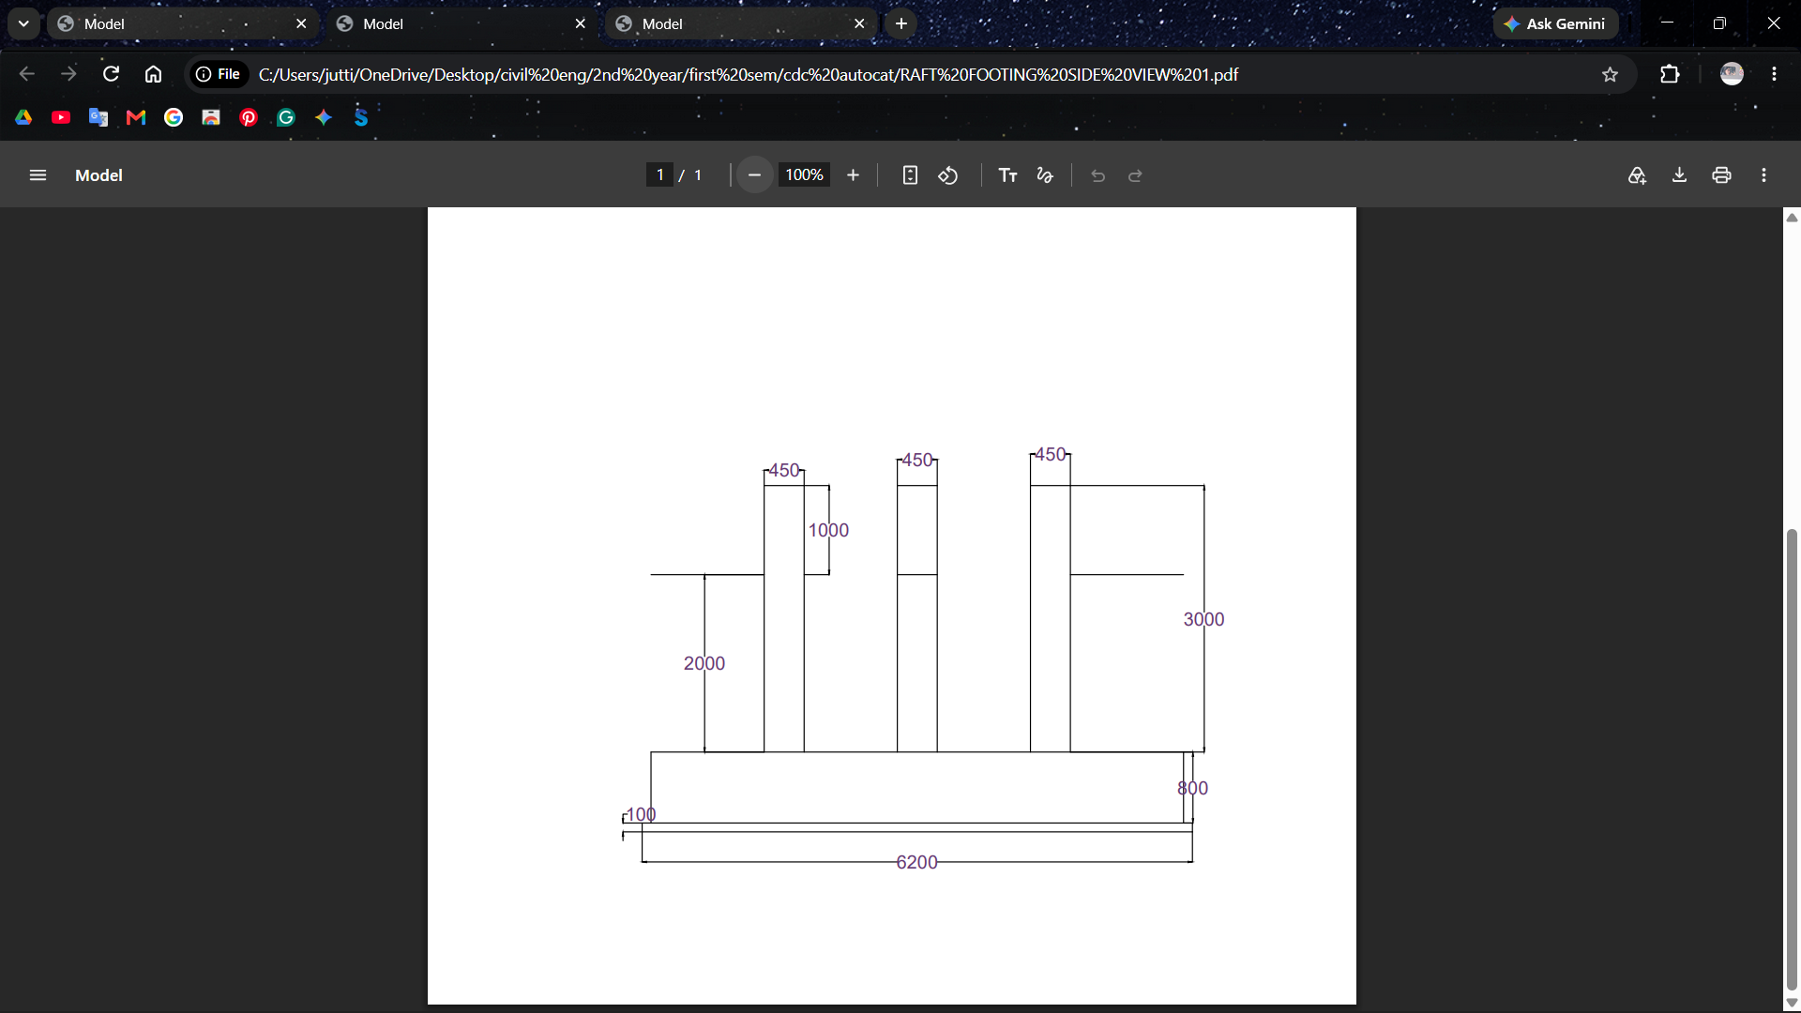
Reinforcement
For a typical academic raft-footing drawing, the following reinforcement details can be shown in AutoCAD. Actual reinforcement must be designed by a qualified structural engineer.
Location | Reinforcement Detail
Bottom reinforcement, both directions | 16 mm diameter bars @ 150 mm c/c
Top reinforcement, both directions | 16 mm diameter bars @ 200 mm c/c
Additional top bars below/around columns | 20 mm diameter bars @ 150 mm c/c
Additional bottom bars in middle strips | 16 mm diameter bars @ 125–150 mm c/c
Pedestal reinforcement | 12 mm diameter vertical bars, 8 nos. minimum
Pedestal ties | 8 mm diameter ties @ 150 mm c/c
Column starter bars | Continue from column reinforcement into the raft as per development length
Clear concrete cover | 75 mm at bottom and sides; 50 mm at top
General Reinforcement Notes
- Provide reinforcement in both longitudinal and transverse directions.
- Bottom reinforcement is mainly provided to resist bending at the middle region between columns.
- Top reinforcement is increased near column locations to resist negative bending moments.
- Extra reinforcement should be provided around columns, pedestals, edges, and openings.
- Bars should be properly lapped and anchored according to the applicable design code.
- Use concrete spacer blocks to maintain the required clear cover.
- Reinforcement should be checked and approved before concreting.

TECHNOLOGY AND SOFTWARE USED

The raft footing drawing was prepared using computer-aided drafting technology to ensure accuracy, clarity, and easy modification of structural details.
- AutoCAD: Used to create the raft footing plan, column layout, grid lines, dimensions, sections, reinforcement details, and construction notes.
- Computer-Aided Design (CAD): Helps produce precise technical drawings with proper scale, layers, line types, hatching, and annotations.
- Structural Drafting Techniques: Used for representing reinforcement bars, pedestals, columns, concrete sections, and footing details according to standard drawing practice.
- Layer Management: Separate layers are used for columns, footing outline, reinforcement, dimensions, text, center lines, and hatching to keep the drawing organized.
- Dimensioning and Annotation Tools: Used to show accurate measurements, levels, bar diameters, spacing, and construction instructions.
- Plotting/Printing Tools: Used to prepare the final drawing sheet at suitable scales, such as 1:50 for the footing plan and 1:20 or 1:25 for sectional details.

AUTOCAD DRAFTING METHODOLOGY

- Set the drawing units to millimetres and establish suitable limits or a working area.
- Create layers for structural concrete, reinforcement, dimensions, text, pipes, water level, and construction/reference lines.
- Draw the outer and inner tank rectangles using Rectangle/Polyline and Offset commands.
- Locate the manhole and pipe openings using Circle, Line, and Offset commands.
- Add dimensions using Linear, Aligned, and Diameter dimension tools.
- Prepare the front elevation by establishing ground level and vertical reference lines.
- Draw columns, beams, tank walls and slabs to the specified sizes.
- Add the ladder, pipe connections, water level and other annotations.
- Develop Section A–A using the elevation and section reference lines.
- Represent reinforcement using lines, offsets, arrays and appropriate hatch patterns.
- Use Trim and Extend to clean intersections and remove unwanted geometry.
- Add text, leaders, notes, legends, schedules and title blocks.
- Check dimensions, alignment, linework and drawing readability before plotting.

DESIGN AND DRAFTING CONSIDERATIONS

- Water-retaining members require careful attention to crack control and water-tightness.
- Adequate concrete cover should be provided according to the applicable code and exposure condition.
- Construction joints and pipe penetrations should be detailed to reduce the possibility of leakage.
- The tank should have sufficient freeboard above the operating water level.
- Access arrangements should allow inspection, cleaning and maintenance.
- Overflow and washout arrangements should discharge safely without damaging the staging or foundation.
- The staging should be checked for gravity loads, lateral loads and seismic effects where applicable.
- Foundation dimensions should be finalized only after considering the actual soil bearing capacity and settlement.
- All dimensions should be coordinated between plan, elevation and section drawings.
- The drawing should be checked for scale, line weights, text height, dimension readability and plotting quality.
- Proper reinforcement detailing should be provided at critical locations such as wall–base junctions, openings and supports.
- Waterproofing treatment and water stops should be provided wherever necessary to prevent seepage and leakage.
- Adequate ventilation should be provided to maintain water quality and prevent the formation of harmful gases.
- Safety features such as handrails, ladders and protective covers should be included for safe operation and maintenance.

DRAWING TOOLS
• Line (L): Used to draw raft footing boundaries, grid lines, column outlines, and section lines.
• Polyline (PL): Used to create connected footing outlines and closed shapes.
• Rectangle (REC): Used for columns, pedestals, and rectangular foundation elements.
• Circle (C): Used where circular column or reinforcement-bar symbols are required.
• Offset (O): Used to create parallel lines for footing thickness, cover, and reinforcement spacing.
• Trim (TR): Used to remove unwanted portions of lines.
• Extend (EX): Used to extend lines up to selected boundaries.
• Move (M): Used to reposition drawing objects.
• Copy (CO): Used to repeat columns, reinforcement bars, and similar details.
• Mirror (MI): Used to create symmetrical reinforcement or footing details.
• Array (AR): Used to generate repeated reinforcement bars at equal spacing.
• Hatch (H): Used to represent concrete, soil, PCC, and sectional portions.
• Dimension (DIM): Used to show footing length, width, thickness, column spacing, and levels.
• Text / MText (MT): Used to add labels, notes, bar details, and titles.
• Layer (LA): Used to organize columns, footing lines, reinforcement, dimensions, text, and hatching separately.
• Block (B): Used to create reusable symbols for columns, reinforcement marks, and section indicators.
• Zoom and Pan: Used to view and edit the drawing accurately at different scales.

MODIFICATION TOOLS
• Move
• Copy
• Rotate
• Mirror
• Scale
• Trim
• Extend
• Offset
• Stretch
• Array
• Fillet
• Chamfer
• Explode
• Erase

DIMENSION TOOLS
• Linear Dimension
• Aligned Dimension
• Angular Dimension
• Radius Dimension
• Diameter Dimension
• Arc Length Dimension
• Ordinate Dimension
• Continue Dimension
• Baseline Dimension
• Dimension Style Manager

DESIGN STANDARDS / REFERENCES

The supplied project reference lists the following Indian Standards and drafting references. They should be consulted in their latest applicable editions when carrying out a real design:
- IS 3370 – Code of Practice for Concrete Structures for the Storage of Liquids.
- IS 456:2000 – Plain and Reinforced Concrete – Code of Practice.
- SP 34 – Handbook on Concrete Reinforcement and Detailing.
- IS 875 – Code of Practice for Design Loads (other than Earthquake) for Buildings and Structures.
- Relevant seismic provisions and applicable local building/water-supply requirements should also be checked for actual construction.

APPLICATIONS OF COMBINED FOOTING
Raft footing is used in the following situations:
- Buildings constructed on weak or low-bearing-capacity soil.
- Multistorey residential and commercial buildings with closely spaced columns.
- Structures where individual footings would overlap due to limited column spacing.
- Buildings carrying heavy loads, such as warehouses, industrial units, and storage facilities.
- Structures requiring reduced differential settlement between columns.
- Basement buildings, where the raft can also act as the basement floor slab.
- Sites with variable soil conditions where uniform load distribution is necessary.
- Water tanks, machine foundations, and other structures requiring a large, stable base.
Raft footing distributes the total structural load over a large area, improves stability, and minimizes unequal settlement of the building.

ADVANTAGES OF COMBINED FOOTING
• Distributes building loads over a large soil area.
• Reduces pressure on soil with low bearing capacity.
• Minimizes differential or unequal settlement between columns.
• Suitable for closely spaced columns where isolated footings may overlap.
• Provides a strong and stable base for multistorey buildings.
• Can serve as the basement floor slab in basement structures.
• Reduces the need for multiple separate footings.
• Improves the overall stability of the structure.
• Suitable for heavy-load structures such as industrial buildings and warehouses.
• Helps achieve more uniform settlement on soils with varying conditions.

RESULT
The raft footing layout and reinforcement detailing were successfully prepared using AutoCAD. The drawing includes the footing plan, column grid, pedestal locations, overall dimensions, sectional views, reinforcement arrangement, and construction notes. AutoCAD enabled accurate drafting, clear annotation, proper scaling, and easy modification of the structural details.
The completed drawing demonstrates how a raft footing distributes loads from multiple columns over a large soil area, making it suitable for weak soil conditions and closely spaced columns. The project improved understanding of raft foundation design concepts and developed practical skills in AutoCAD-based structural drafting.

CONCLUSION
The raft footing drawing was successfully prepared using AutoCAD with proper planning, dimensions, sections, reinforcement details, and construction notes. A raft foundation is an effective solution for structures built on weak soil, carrying heavy loads, or having closely spaced columns. It distributes the total load over a large area and helps reduce soil pressure and differential settlement.
This project demonstrates the importance of accurate drafting in structural engineering. AutoCAD makes it easier to prepare clear, precise, and editable foundation drawings, which improves communication between engineers, contractors, and site workers. The work also enhanced practical knowledge of raft footing components, reinforcement detailing, dimensioning, layer management, and other AutoCAD drafting tools.

LEARNING OUTCOMES
After completing this project, the following learning outcomes were achieved:
- Understood the purpose, components, and applications of raft footing.
- Learned when raft foundations are preferred over isolated footings.
- Gained knowledge of load distribution and settlement control in foundations.
- Developed the ability to prepare a raft footing plan in AutoCAD.
- Learned to draw column grids, footing outlines, pedestals, and sectional views.
- Improved skills in dimensioning, annotation, hatching, layer management, and scaling.
- Learned to represent top and bottom reinforcement details in structural drawings.
- Understood the importance of clear construction notes and proper drawing presentation.
- Developed practical confidence in using AutoCAD for civil and structural engineering drafting.

REFERENCES

- Supplied Computer Aided Drafting Software Project reference pages: Water Tank Design and Drafting Using AutoCAD.
- IS 3370 – Concrete Structures for the Storage of Liquids.
- IS 456:2000 – Plain and Reinforced Concrete – Code of Practice.
- SP 34 – Handbook on Concrete Reinforcement and Detailing.
- IS 875 – Design Loads for Buildings and Structures.
- Autodesk AutoCAD documentation and standard drafting practices.



